1. **Different Layout Design**

**Main.XML**

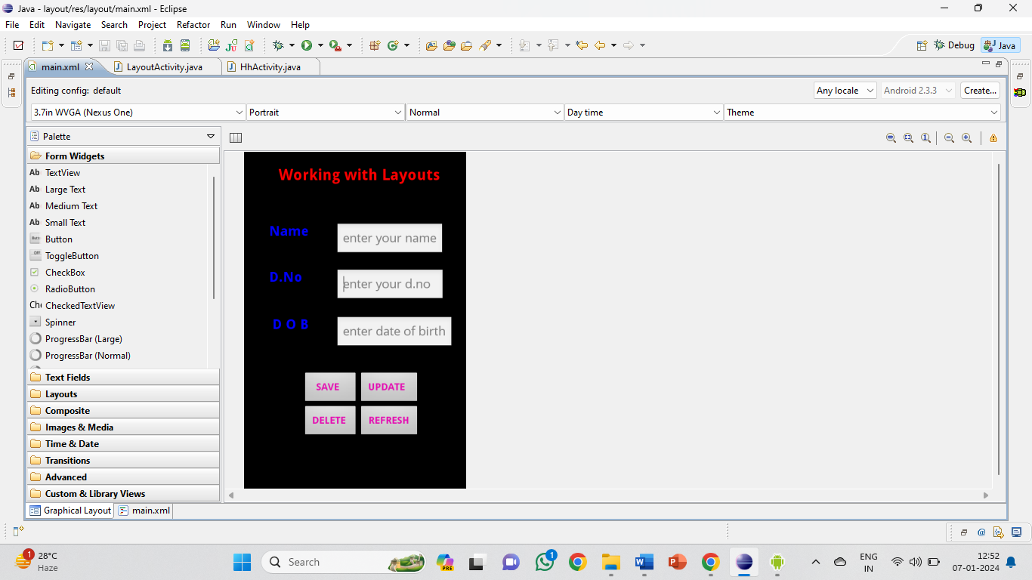

<?xml version=*"1.0"* encoding=*"utf-8"*?>

<LinearLayout xmlns:android=*"http://schemas.android.com/apk/res/android"*

android:layout_width=*"match_parent"*

android:layout_height=*"wrap_content"*

android:orientation=*"vertical"* >

<LinearLayout

android:id=*"@+id/linearLayout1"*

android:layout_width=*"match_parent"*

android:layout_height=*"match_parent"*

android:orientation=*"vertical"* >

<TextView

android:id=*"@+id/textView1"*

android:layout_width=*"match_parent"*

android:layout_height=*"wrap_content"*

android:layout_marginLeft=*"50dp"*

android:layout_marginTop=*"20dp"*

android:text=*"Working with Layouts"*

android:textAppearance=*"?android:attr/textAppearanceLarge"*

android:textColor=*"#ff0000"*

android:textStyle=*"bold"* />

</LinearLayout>

<RelativeLayout

android:id=*"@+id/relativeLayout1"*

android:layout_width=*"match_parent"*

android:layout_height=*"491dp"* >

<TextView

android:id=*"@+id/textView2"*

android:layout_width=*"wrap_content"*

android:layout_height=*"wrap_content"*

android:layout_alignParentLeft=*"true"*

android:layout_alignParentTop=*"true"*

android:layout_marginLeft=*"36dp"*

android:layout_marginTop=*"56dp"*

android:text=*"Name"*

android:textStyle=*"bold"*

android:textColor=*"#0000ff"*

android:textSize=*"20dp"* />

<EditText

android:id=*"@+id/editText1"*

android:layout_width=*"wrap_content"*

android:layout_height=*"wrap_content"*

android:layout_alignParentRight=*"true"*

android:layout_alignTop=*"@+id/textView2"*

android:layout_marginRight=*"32dp"*

android:hint=*"enter your name"*

android:text=*""* />

<TextView

android:id=*"@+id/textView3"*

android:layout_width=*"wrap_content"*

android:layout_height=*"wrap_content"*

android:layout_alignLeft=*"@+id/textView2"*

android:layout_below=*"@+id/editText1"*

android:layout_marginTop=*"18dp"*

android:text=*"D.No"*

android:textStyle=*"bold"*

android:textColor=*"#0000ff"*

android:textSize=*"20dp"* />

<EditText

android:id=*"@+id/editText2"*

android:layout_width=*"wrap_content"*

android:layout_height=*"wrap_content"*

android:layout_alignLeft=*"@+id/editText1"*

android:layout_alignTop=*"@+id/textView3"*

android:hint=*"enter your d.no "*

android:text=*""* >

</EditText>

<EditText

android:id=*"@+id/editText3"*

android:layout_width=*"wrap_content"*

android:layout_height=*"wrap_content"*

android:layout_alignLeft=*"@+id/editText2"*

android:layout_below=*"@+id/editText2"*

android:layout_marginTop=*"20dp"*

android:hint=*"enter date of birth"*

android:text=*""* />

<TextView

android:id=*"@+id/textView4"*

android:layout_width=*"wrap_content"*

android:layout_height=*"wrap_content"*

android:layout_alignRight=*"@+id/textView2"*

android:layout_alignTop=*"@+id/editText3"*

android:text=*"D O B"*

android:textStyle=*"bold"*

android:textColor=*"#0000ff"*

android:textSize=*"20dp"* />

<TableLayout

android:id=*"@+id/tableLayout1"*

android:layout_width=*"wrap_content"*

android:layout_height=*"wrap_content"*

android:layout_alignParentLeft=*"true"*

android:layout_below=*"@+id/editText3"*

android:layout_marginTop=*"32dp"* >

<TableRow

android:id=*"@+id/tableRow1"*

android:layout_width=*"wrap_content"*

android:layout_height=*"wrap_content"* >

</TableRow>

<TableRow

android:id=*"@+id/tableRow2"*

android:layout_width=*"wrap_content"*

android:layout_height=*"wrap_content"* >

</TableRow>

<TableRow

android:id=*"@+id/tableRow3"*

android:layout_width=*"wrap_content"*

android:layout_height=*"wrap_content"* >

</TableRow>

<TableRow

android:id=*"@+id/tableRow4"*

android:layout_width=*"wrap_content"*

android:layout_height=*"wrap_content"* >

</TableRow>

</TableLayout>

<TableLayout

android:id=*"@+id/tableLayout2"*

android:layout_width=*"wrap_content"*

android:layout_height=*"wrap_content"*

android:layout_alignRight=*"@+id/editText3"*

android:layout_alignTop=*"@+id/tableLayout1"*

android:layout_toRightOf=*"@+id/textView3"* >

<TableRow

android:id=*"@+id/tableRow5"*

android:layout_width=*"wrap_content"*

android:layout_height=*"wrap_content"* >

<Button

android:id=*"@+id/save"*

android:layout_width=*"wrap_content"*

android:layout_height=*"wrap_content"*

android:text=*" SAVE "*

android:textStyle=*"bold"*

android:textColor=*"#E40EB2"*/>

<Button

android:id=*"@+id/up"*

android:layout_width=*"wrap_content"*

android:layout_height=*"wrap_content"*

android:text=*" UPDATE "*

android:textStyle=*"bold"*

android:textColor=*"#E40EB2"* />

</TableRow>

<TableRow

android:id=*"@+id/tableRow6"*

android:layout_width=*"wrap_content"*

android:layout_height=*"wrap_content"* >

<Button

android:id=*"@+id/del"*

android:layout_width=*"wrap_content"*

android:layout_height=*"wrap_content"*

android:text=*" DELETE "*

android:textStyle=*"bold"*

android:textColor=*"#E40EB2"* />

<Button

android:id=*"@+id/ref"*

android:layout_width=*"wrap_content"*

android:layout_height=*"wrap_content"*

android:text=*" REFRESH "*

android:textStyle=*"bold"*

android:textColor=*"#E40EB2"* />

</TableRow>

<TableRow

android:id=*"@+id/tableRow7"*

android:layout_width=*"wrap_content"*

android:layout_height=*"wrap_content"* >

</TableRow>

<TableRow

android:id=*"@+id/tableRow8"*

android:layout_width=*"wrap_content"*

android:layout_height=*"wrap_content"* >

</TableRow>

</TableLayout>

</RelativeLayout>

</LinearLayout>

**LayoutActivity.Java**

**package** com.lay;

**import** com.lay.LayoutActivity;

**import** android.app.Activity;

**import** android.os.Bundle;

**import** android.view.View;

**import** android.widget.Button;

**import** android.widget.Toast;

**public** **class** LayoutActivity **extends** Activity

{

Button save,del,up,ref;

/** Called when the activity is first created. */

@Override

**public** **void** onCreate(Bundle savedInstanceState)

{

**super**.onCreate(savedInstanceState);

setContentView(R.layout.*main*);

save=(Button)findViewById(R.id.*save*);

up=(Button)findViewById(R.id.*up*);

del=(Button)findViewById(R.id.*del*);

ref=(Button)findViewById(R.id.*ref*);

save.setOnClickListener(**new** View.OnClickListener()

{

**public** **void** onClick(View v)

{

// If incorrect, show a toast message

Toast.*makeText*(LayoutActivity.**this**, "Your Data Saved", Toast.*LENGTH_SHORT*).show();

}

});

up.setOnClickListener(**new** View.OnClickListener()

{

**public** **void** onClick(View v)

{

// If incorrect, show a toast message

Toast.*makeText*(LayoutActivity.**this**, "Your Data Updated", Toast.*LENGTH_SHORT*).show();

}

});

del.setOnClickListener(**new** View.OnClickListener()

{

**public** **void** onClick(View v)

{

// If incorrect, show a toast message

Toast.*makeText*(LayoutActivity.**this**, "Your Data Deleted", Toast.*LENGTH_SHORT*).show();

}

});

ref.setOnClickListener(**new** View.OnClickListener()

{

**public** **void** onClick(View v)

{

finish();

}

});

}

}

**Output**

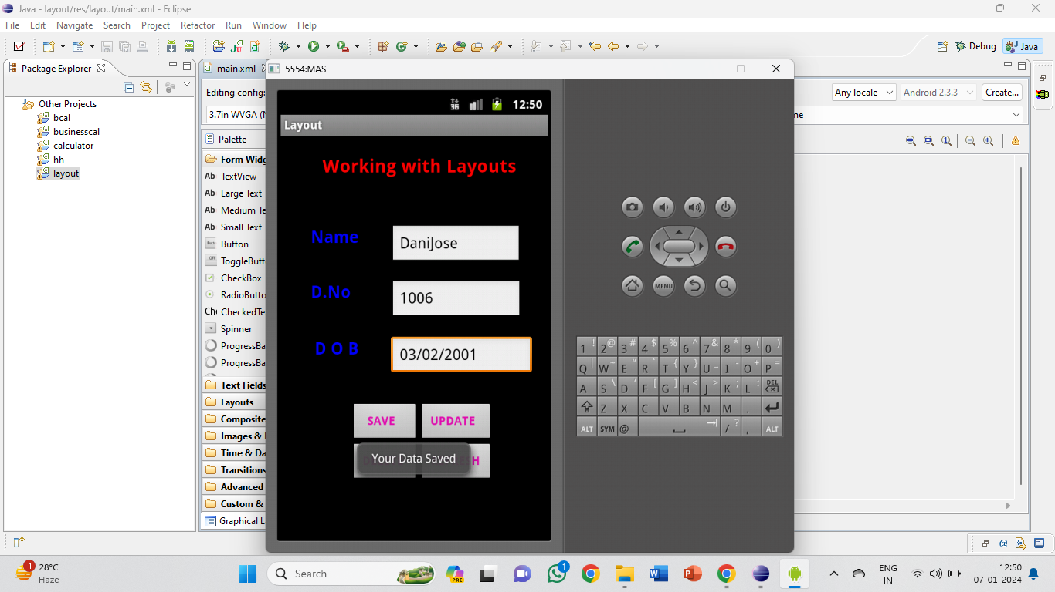 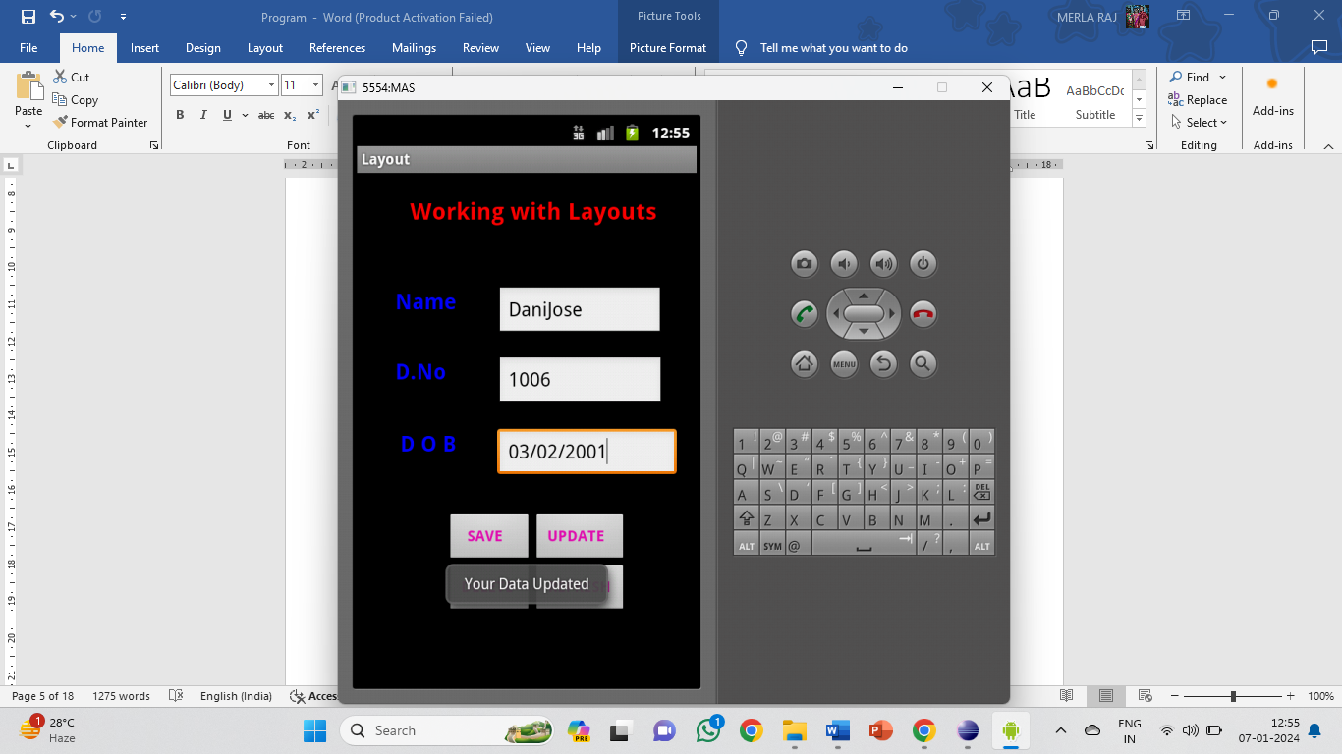 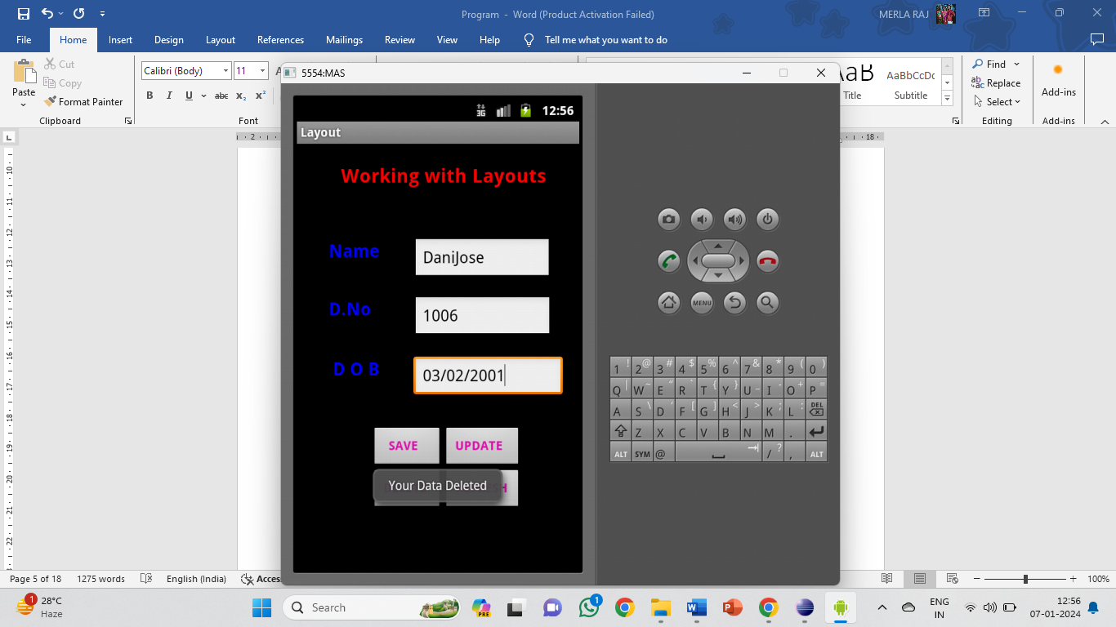

1. **Arithmetic Operations**

**Main.XML**

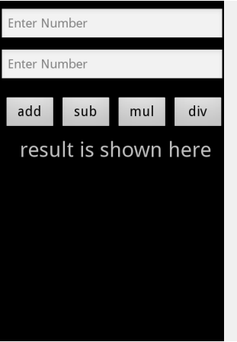

<?xml version=*"1.0"* encoding=*"utf-8"*?>

<LinearLayout xmlns:android=*"http://schemas.android.com/apk/res/android"*

android:layout_width=*"fill_parent"*

android:layout_height=*"fill_parent"*

android:orientation=*"vertical"* >

<EditText

android:id=*"@+id/num1"*

android:hint=*"Enter Number"*

android:layout_marginTop=*"10dp"*

android:inputType=*"number"*

android:layout_width=*"match_parent"*

android:layout_height=*"wrap_content"* />

<EditText

android:id=*"@+id/num2"*

android:hint=*"Enter Number"*

android:layout_marginTop=*"10dp"*

android:inputType=*"number"*

android:layout_width=*"match_parent"*

android:layout_height=*"wrap_content"* />

<LinearLayout

android:id=*"@+id/linearLayout1"*

android:layout_width=*"match_parent"*

android:layout_height=*"wrap_content"*

android:layout_marginTop=*"20dp"* >

<Button

android:id=*"@+id/add"*

android:layout_width=*"0dp"*

android:layout_height=*"wrap_content"*

android:layout_marginLeft=*"5dp"*

android:layout_weight=*"1"*

android:text=*"add"*

android:textSize=*"20dp"* />

<Button

android:id=*"@+id/sub"*

android:layout_width=*"0dp"*

android:layout_height=*"wrap_content"*

android:layout_marginLeft=*"5dp"*

android:layout_weight=*"1"*

android:text=*"sub"*

android:textSize=*"20dp"* />

<Button

android:id=*"@+id/mul"*

android:layout_width=*"0dp"*

android:layout_height=*"wrap_content"*

android:layout_marginLeft=*"5dp"*

android:layout_weight=*"1"*

android:text=*"mul"*

android:textSize=*"20dp"* />

<Button

android:id=*"@+id/div"*

android:layout_width=*"0dp"*

android:layout_height=*"wrap_content"*

android:layout_marginLeft=*"5dp"*

android:layout_weight=*"1"*

android:text=*"div"*

android:textSize=*"20dp"* />

</LinearLayout>

<TextView

android:id=*"@+id/ans"*

android:layout_gravity=*"center"*

android:layout_marginLeft=*"5dp"*

android:textSize=*"30dp"*

android:layout_marginTop=*"10dp"*

android:layout_width=*"wrap_content"*

android:layout_height=*"wrap_content"*

android:text=*"result is shown here"* />

</LinearLayout>

**Activity.Java**

**package** com.cal;

**import** android.app.Activity;

**import** android.os.Bundle;

**import** android.view.View;

**import** android.widget.Button;

**import** android.widget.EditText;

**import** android.widget.TextView;

**public** **class** CalculatorActivity **extends** Activity {

EditText no1,no2;

TextView ans;

**int** num1,num2;

@Override

**public** **void** onCreate(Bundle savedInstanceState) {

**super**.onCreate(savedInstanceState);

setContentView(R.layout.*main*);

no1 = (EditText) findViewById(R.id.*num1*);

no2 = (EditText) findViewById(R.id.*num2*);

ans = (TextView) findViewById(R.id.*ans*);

Button btnAdd = (Button) findViewById(R.id.*add*);

Button btnSubtract = (Button) findViewById(R.id.*sub*);

Button btnMultiply = (Button) findViewById(R.id.*mul*);

Button btnDivide = (Button) findViewById(R.id.*div*);

btnAdd.setOnClickListener(**new** View.OnClickListener() {

**public** **void** onClick(View view) {

performOperation('+');

}

});

btnSubtract.setOnClickListener(**new** View.OnClickListener() {

**public** **void** onClick(View view) {

performOperation('-');

}

});

btnMultiply.setOnClickListener(**new** View.OnClickListener() {

**public** **void** onClick(View view) {

performOperation('*');

}

});

btnDivide.setOnClickListener(**new** View.OnClickListener() {

**public** **void** onClick(View view) {

performOperation('/');

}

});

}

**private** **void** performOperation(**char** operation) {

String num1Str = no1.getText().toString();

String num2Str = no2.getText().toString();

**if** (!num1Str.isEmpty() && !num2Str.isEmpty()) {

**double** num1 = Double.*parseDouble*(num1Str);

**double** num2 = Double.*parseDouble*(num2Str);

**double** result = 0;

**switch** (operation) {

**case** '+':

result = num1 + num2;

**break**;

**case** '-':

result = num1 - num2;

**break**;

**case** '*':

result = num1 * num2;

**break**;

**case** '/':

**if** (num2 != 0) {

result = num1 / num2;

} **else** {

ans.setText("Cannot divide by zero");

**return**;

}

**break**;

}

ans.setText("Result: " + result);

} **else** {

ans.setText("Please enter valid numbers");

}

}

}

**Output**

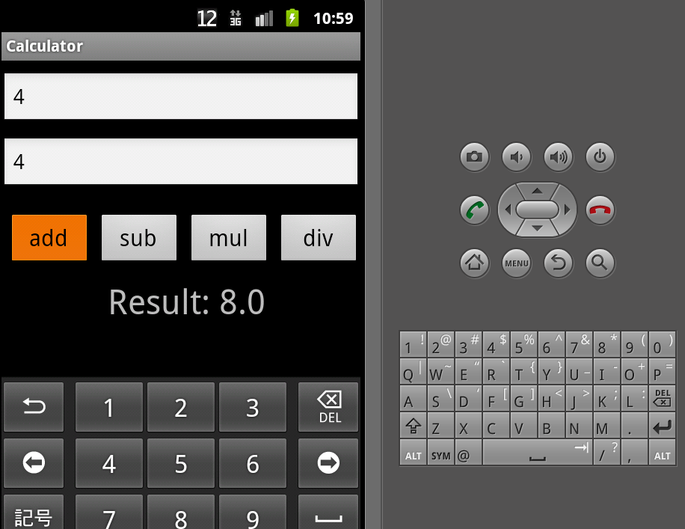

1. **Intent**

**Main.xml**

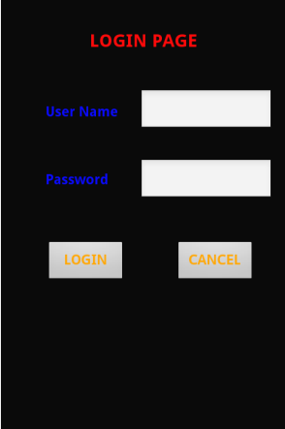

<?xml version=*"1.0"* encoding=*"utf-8"*?>

<LinearLayout xmlns:android=*"http://schemas.android.com/apk/res/android"*

android:layout_width=*"fill_parent"*

android:layout_height=*"fill_parent"*

android:orientation=*"vertical"* >

<RelativeLayout

android:id=*"@+id/relativeLayout1"*

android:layout_width=*"match_parent"*

android:layout_height=*"match_parent"* >

<TextView

android:id=*"@+id/textView1"*

android:layout_width=*"wrap_content"*

android:layout_height=*"wrap_content"*

android:layout_alignParentTop=*"true"*

android:layout_centerHorizontal=*"true"*

android:layout_marginTop=*"36dp"*

android:text=*"LOGIN PAGE"*

android:textColor=*"#ff0000"*

android:textSize=*"20dp"*

android:textStyle=*"bold"* />

<TextView

android:id=*"@+id/textView2"*

android:layout_width=*"wrap_content"*

android:layout_height=*"wrap_content"*

android:layout_alignParentLeft=*"true"*

android:layout_below=*"@+id/textView1"*

android:layout_marginLeft=*"50dp"*

android:layout_marginTop=*"58dp"*

android:text=*"User Name"*

android:textColor=*"#0000ff"*

android:textSize=*"15dp"*

android:textStyle=*"bold"* />

<EditText

android:id=*"@+id/un"*

android:layout_width=*"wrap_content"*

android:layout_height=*"wrap_content"*

android:layout_below=*"@+id/textView1"*

android:layout_marginLeft=*"24dp"*

android:layout_marginTop=*"42dp"*

android:layout_toRightOf=*"@+id/textView2"*

android:width=*"150dp"* />

<EditText

android:id=*"@+id/pas"*

android:layout_width=*"wrap_content"*

android:layout_height=*"wrap_content"*

android:layout_alignLeft=*"@+id/un"*

android:layout_below=*"@+id/un"*

android:layout_marginTop=*"30dp"*

android:width=*"150dp"* />

<TextView

android:id=*"@+id/textView3"*

android:layout_width=*"wrap_content"*

android:layout_height=*"wrap_content"*

android:layout_alignLeft=*"@+id/textView2"*

android:layout_alignTop=*"@+id/pas"*

android:layout_marginTop=*"14dp"*

android:text=*"Password"*

android:textColor=*"#0000ff"*

android:textSize=*"15dp"*

android:textStyle=*"bold"* />

<Button

android:id=*"@+id/login"*

android:layout_width=*"wrap_content"*

android:layout_height=*"wrap_content"*

android:layout_alignLeft=*"@+id/textView3"*

android:layout_below=*"@+id/pas"*

android:layout_marginTop=*"44dp"*

android:text=*"LOGIN"*

android:textColor=*"#ffa500"*

android:textSize=*"15dp"*

android:textStyle=*"bold"*

android:width=*"90dp"* />

<Button

android:id=*"@+id/cancel"*

android:layout_width=*"wrap_content"*

android:layout_height=*"wrap_content"*

android:layout_alignRight=*"@+id/pas"*

android:layout_alignTop=*"@+id/login"*

android:layout_marginRight=*"20dp"*

android:text=*"CANCEL"*

android:textColor=*"#ffa500"*

android:textSize=*"15dp"*

android:textStyle=*"bold"*

android:width=*"90dp"* />

</RelativeLayout>

<RelativeLayout

android:id=*"@+id/relativeLayout1"*

android:layout_width=*"match_parent"*

android:layout_height=*"match_parent"* >

<TextView

android:id=*"@+id/textView1"*

android:layout_width=*"wrap_content"*

android:layout_height=*"wrap_content"*

android:layout_alignParentTop=*"true"*

android:layout_centerHorizontal=*"true"*

android:layout_marginTop=*"36dp"*

android:text=*"LOGIN PAGE"*

android:textColor=*"#ff0000"*

android:textSize=*"20dp"*

android:textStyle=*"bold"* />

<TextView

android:id=*"@+id/textView2"*

android:layout_width=*"wrap_content"*

android:layout_height=*"wrap_content"*

android:layout_alignParentLeft=*"true"*

android:layout_below=*"@+id/textView1"*

android:layout_marginLeft=*"50dp"*

android:layout_marginTop=*"58dp"*

android:text=*"User Name"*

android:textColor=*"#0000ff"*

android:textSize=*"15dp"*

android:textStyle=*"bold"* />

<EditText

android:id=*"@+id/un"*

android:layout_width=*"wrap_content"*

android:layout_height=*"wrap_content"*

android:layout_below=*"@+id/textView1"*

android:layout_marginLeft=*"24dp"*

android:layout_marginTop=*"42dp"*

android:layout_toRightOf=*"@+id/textView2"*

android:width=*"150dp"* >

<requestFocus />

</EditText>

<TextView

android:id=*"@+id/textView3"*

android:layout_width=*"wrap_content"*

android:layout_height=*"wrap_content"*

android:layout_alignLeft=*"@+id/textView2"*

android:layout_below=*"@+id/editText1"*

android:layout_marginTop=*"30dp"*

android:text=*"Password"*

android:textColor=*"#0000ff"*

android:textSize=*"15dp"*

android:textStyle=*"bold"* />

<EditText

android:id=*"@+id/pas"*

android:layout_width=*"wrap_content"*

android:layout_height=*"wrap_content"*

android:layout_alignLeft=*"@+id/editText1"*

android:layout_below=*"@+id/editText1"*

android:layout_marginTop=*"16dp"*

android:width=*"150dp"* />

<Button

android:id=*"@+id/login"*

android:layout_width=*"wrap_content"*

android:layout_height=*"wrap_content"*

android:layout_below=*"@+id/editText2"*

android:layout_marginTop=*"28dp"*

android:layout_toLeftOf=*"@+id/editText2"*

android:text=*"LOGIN"*

android:textColor=*"#ffa500"*

android:textSize=*"15dp"*

android:textStyle=*"bold"*

android:width=*"90dp"* />

<Button

android:id=*"@+id/cancel"*

android:layout_width=*"wrap_content"*

android:layout_height=*"wrap_content"*

android:layout_alignLeft=*"@+id/editText2"*

android:layout_alignTop=*"@+id/login"*

android:layout_marginLeft=*"26dp"*

android:text=*"CANCEL"*

android:textColor=*"#ffa500"*

android:textSize=*"15dp"*

android:textStyle=*"bold"*

android:width=*"90dp"* />

</RelativeLayout>

</LinearLayout>

**First.Xml**

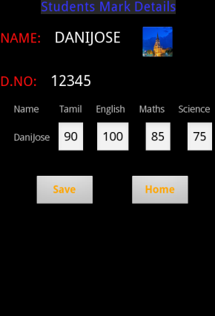

<?xml version=*"1.0"* encoding=*"utf-8"*?>

<LinearLayout xmlns:android=*"http://schemas.android.com/apk/res/android"*

android:layout_width=*"match_parent"*

android:layout_height=*"match_parent"*

android:orientation=*"vertical"* >

<LinearLayout

android:id=*"@+id/linearLayout1"*

android:layout_width=*"match_parent"*

android:layout_height=*"wrap_content"*

android:orientation=*"vertical"* >

<TextView

android:id=*"@+id/textView1"*

android:layout_width=*"wrap_content"*

android:layout_height=*"wrap_content"*

android:layout_marginLeft=*"60dp"*

android:layout_marginRight=*"60dp"*

android:text=*"Students Mark Details"*

android:textColor=*"#0e0eff"*

android:textSize=*"20dp"* />

</LinearLayout>

<LinearLayout

android:id=*"@+id/linearLayout2"*

android:layout_width=*"match_parent"*

android:layout_height=*"wrap_content"* >

<TextView

android:id=*"@+id/textView2"*

android:layout_width=*"wrap_content"*

android:layout_height=*"wrap_content"*

android:text=*"NAME:"*

android:textSize=*"20dp"*

android:textColor=*"#ff0e0e"*

android:layout_marginTop=*"20dp"*/>

<TextView

android:id=*"@+id/textView3"*

android:layout_width=*"wrap_content"*

android:layout_height=*"wrap_content"*

android:text=*"DANIJOSE"*

android:layout_marginTop=*"20dp"*

android:layout_marginLeft=*"20dp"*

android:textAppearance=*"?android:attr/textAppearanceLarge"* />

<ImageView

android:id=*"@+id/imageView1"*

android:layout_width=*"wrap_content"*

android:layout_height=*"wrap_content"*

android:layout_marginLeft=*"30dp"*

android:layout_marginTop=*"15dp"*

android:src=*"@drawable/a"* />

</LinearLayout>

<LinearLayout

android:id=*"@+id/linearLayout3"*

android:layout_width=*"match_parent"*

android:layout_height=*"wrap_content"* >

<TextView

android:id=*"@+id/textView2"*

android:layout_width=*"wrap_content"*

android:layout_height=*"wrap_content"*

android:text=*"D.NO:"*

android:layout_marginTop=*"20dp"*

android:textSize=*"20dp"*

android:textColor=*"#ff0e0e"* />

<TextView

android:id=*"@+id/textView3"*

android:layout_width=*"wrap_content"*

android:layout_height=*"wrap_content"*

android:text=*"12345"*

android:layout_marginTop=*"20dp"*

android:layout_marginLeft=*"20dp"*

android:textAppearance=*"?android:attr/textAppearanceLarge"* />

</LinearLayout>

<TableRow

android:id=*"@+id/tableRow1"*

android:layout_width=*"match_parent"*

android:layout_height=*"wrap_content"* >

<TextView

android:id=*"@+id/textView4"*

android:layout_width=*"wrap_content"*

android:layout_height=*"wrap_content"*

android:text=*"Name"*

android:layout_marginTop=*"20dp"*

android:layout_marginLeft=*"20dp"* />

<TextView

android:id=*"@+id/textView6"*

android:layout_width=*"wrap_content"*

android:layout_height=*"wrap_content"*

android:layout_marginTop=*"20dp"*

android:layout_marginLeft=*"30dp"*

android:text=*"Tamil"* />

<TextView

android:id=*"@+id/textView7"*

android:layout_width=*"wrap_content"*

android:layout_height=*"wrap_content"*

android:layout_marginTop=*"20dp"*

android:layout_marginLeft=*"20dp"*

android:text=*"English"* />

<TextView

android:id=*"@+id/textView8"*

android:layout_width=*"wrap_content"*

android:layout_height=*"wrap_content"*

android:layout_marginTop=*"20dp"*

android:layout_marginLeft=*"20dp"*

android:text=*"Maths"* />

<TextView

android:id=*"@+id/textView9"*

android:layout_width=*"wrap_content"*

android:layout_height=*"wrap_content"*

android:layout_marginTop=*"20dp"*

android:layout_marginLeft=*"20dp"*

android:text=*"Science"* />

</TableRow>

<TableLayout

android:id=*"@+id/tableLayout1"*

android:layout_width=*"match_parent"*

android:layout_height=*"wrap_content"* >

<TableRow

android:id=*"@+id/tableRow2"*

android:layout_width=*"wrap_content"*

android:layout_height=*"wrap_content"* >

<TextView

android:id=*"@+id/textView5"*

android:layout_width=*"wrap_content"*

android:layout_height=*"wrap_content"*

android:layout_marginLeft=*"20dp"*

android:text=*"DaniJose"*

android:layout_marginTop=*"10dp"* />

<EditText

android:id=*"@+id/editText2"*

android:layout_width=*"wrap_content"*

android:layout_height=*"wrap_content"*

android:layout_marginLeft=*"10dp"*

android:layout_marginTop=*"10dp"*

android:text=*"90"* />

<EditText

android:id=*"@+id/editText1"*

android:layout_width=*"wrap_content"*

android:layout_height=*"wrap_content"*

android:layout_marginLeft=*"15dp"*

android:layout_marginTop=*"10dp"*

android:text=*"100"* >

<requestFocus />

</EditText>

<EditText

android:id=*"@+id/editText3"*

android:layout_width=*"wrap_content"*

android:layout_height=*"wrap_content"*

android:layout_marginLeft=*"20dp"*

android:layout_marginTop=*"10dp"*

android:text=*"85"* />

<EditText

android:id=*"@+id/editText4"*

android:layout_width=*"wrap_content"*

android:layout_height=*"wrap_content"*

android:layout_marginLeft=*"20dp"*

android:layout_marginTop=*"10dp"*

android:text=*"75"*/>

</TableRow>

</TableLayout>

<LinearLayout

android:id=*"@+id/linearLayout4"*

android:layout_width=*"match_parent"*

android:layout_height=*"wrap_content"* >

<Button

android:id=*"@+id/Save"*

android:layout_width=*"wrap_content"*

android:layout_height=*"wrap_content"*

android:text=*"Save"*

android:layout_marginLeft=*"50dp"*

android:layout_marginTop=*"30dp"*

android:textColor=*"#ffa500"*

android:textSize=*"15dp"*

android:textStyle=*"bold"*

android:width=*"90dp"* />

<Button

android:id=*"@+id/first"*

android:layout_width=*"wrap_content"*

android:layout_height=*"wrap_content"*

android:text=*"Home"*

android:layout_marginLeft=*"50dp"*

android:layout_marginTop=*"30dp"*

android:textColor=*"#ffa500"*

android:textSize=*"15dp"*

android:textStyle=*"bold"*

android:width=*"90dp"* />

</LinearLayout>

</LinearLayout>

**Activity.Java**

package com.hh;

import android.app.Activity;

import android.os.Bundle;

import android.content.Intent;

import android.view.View;

import android.widget.Button;

import android.widget.EditText;

import android.widget.Toast;

public class HhActivity extends Activity {

Button b1,b2;

EditText ed1,ed2;

/** Called when the activity is first created. */

@Override

public void onCreate(Bundle savedInstanceState) {

super.onCreate(savedInstanceState);

setContentView(R.layout.main);

ed1 = (EditText)findViewById(R.id.un);

ed2 = (EditText)findViewById(R.id.pas);

b1=(Button)findViewById(R.id.login);

b1.setOnClickListener(new View.OnClickListener()

{

public void onClick(View v)

{

if(ed1.getText().toString().equals("hi") && d2.getText().toString().equals("mas"))

{

Intent in = new Intent(HhActivity.this, login.class);

startActivity(in);

}

else

{

// If incorrect, show a toast message

Toast.makeText(HhActivity.this, "Incorrect username or password",

Toast.LENGTH_SHORT).show();

}

}

});

b2=(Button)findViewById(R.id.cancel);

b2.setOnClickListener(new View.OnClickListener() {

public void onClick(View v)

{

finish();

}

});

}

}

**Login.java**

package com.hh;

import android.app.Activity;

import android.content.Intent;

import android.os.Bundle;

import android.view.View;

import android.widget.Button;

import android.widget.Toast;

public class login extends Activity

{

/** Called when the activity is first created. */

public void onCreate(Bundle savedInstanceState)

{

super.onCreate(savedInstanceState);

setContentView(R.layout.first);

Button b11,b22;

b11=(Button)findViewById(R.id.Save);

b11.setOnClickListener(new View.OnClickListener()

{

public void onClick(View view)

{

// If incorrect, show a toast message Toast.makeText(login.this, "Data Saved", Toast.LENGTH_SHORT).show();

}

});

b22=(Button)findViewById(R.id.first);

b22.setOnClickListener(new View.OnClickListener()

{

public void onClick(View view)

{

Intent in = new Intent(login.this,HhActivity.class);

startActivity(in);

}

});

}

}

**AndroidManifest.xml**

<?xml version=*"1.0"* encoding=*"utf-8"*?>

<manifest xmlns:android=*"http://schemas.android.com/apk/res/android"*

package=*"com.hh"*

android:versionCode=*"1"*

android:versionName=*"1.0"* >

<uses-sdk android:minSdkVersion=*"10"* />

<application

android:allowBackup=*"true"*

android:icon=*"@drawable/ic_launcher"*

android:label=*"@string/app_name"* >

<activity

android:name=*".HhActivity"*

android:label=*"@string/app_name"* >

<intent-filter>

<action android:name=*"android.intent.action.MAIN"* />

<category android:name=*"android.intent.category.LAUNCHER"* />

</intent-filter>

</activity>

<activity android:name=*"login"*></activity>

</application>

</manifest>

**Output**

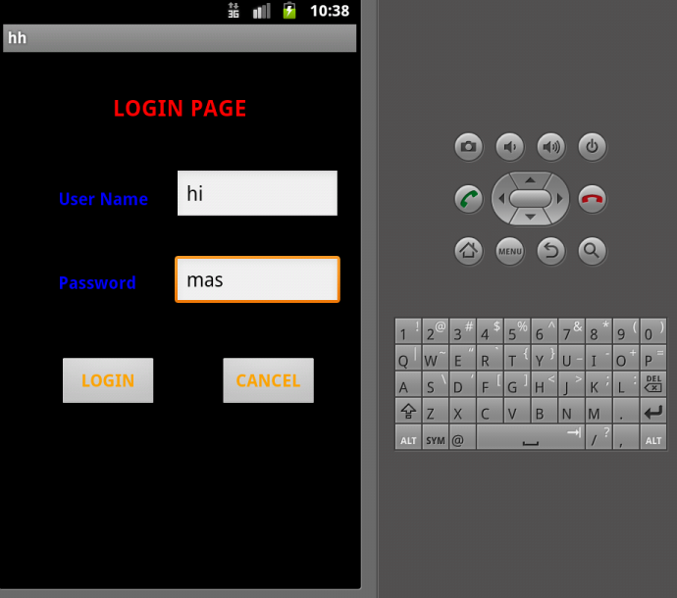 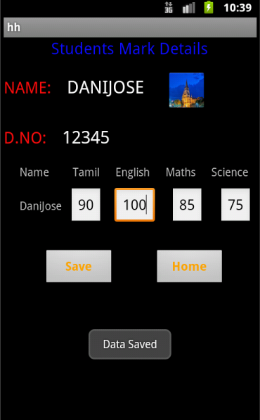

1. **DATABASE**

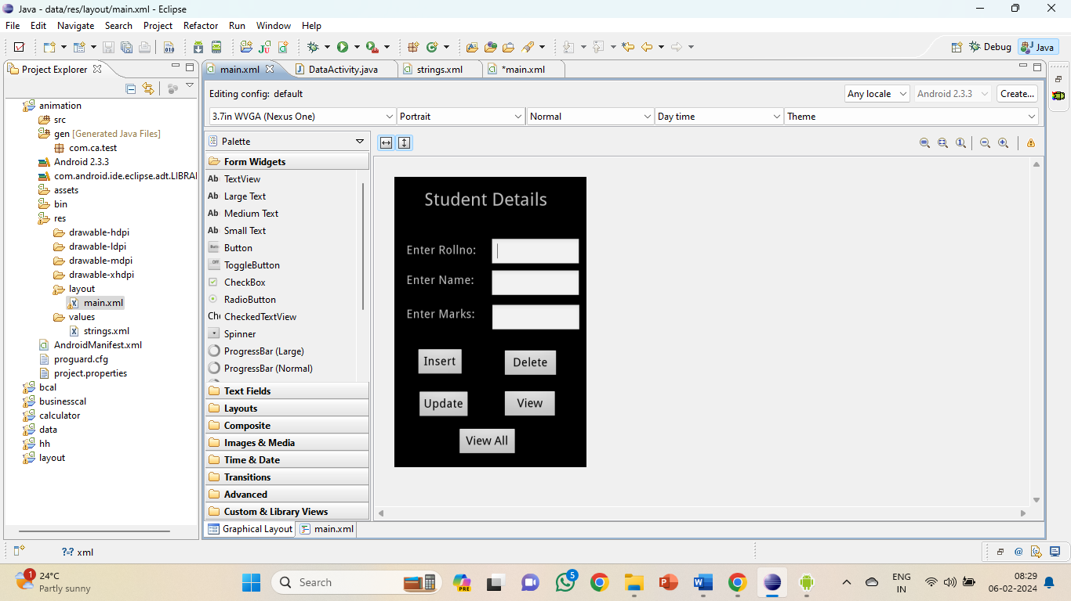

**XML CODE**

<?xml version=*"1.0"* encoding=*"utf-8"*?>

<AbsoluteLayout xmlns:android=*"http://schemas.android.com/apk/res/android"*

android:layout_width=*"match_parent"*

android:layout_height=*"match_parent"*>

<TextView

android:layout_width=*"wrap_content"*

android:layout_height=*"wrap_content"*

android:layout_x=*"50dp"*

android:layout_y=*"20dp"*

android:text=*"Student Details"*

android:textSize=*"30sp"* />

<TextView

android:layout_width=*"wrap_content"*

android:layout_height=*"wrap_content"*

android:layout_x=*"20dp"*

android:layout_y=*"110dp"*

android:text=*"Enter Rollno:"*

android:textSize=*"20sp"* />

<TextView

android:layout_width=*"wrap_content"*

android:layout_height=*"wrap_content"*

android:layout_x=*"20dp"*

android:layout_y=*"160dp"*

android:text=*"Enter Name:"*

android:textSize=*"20sp"* />

<EditText

android:id=*"@+id/Rollno"*

android:layout_width=*"150dp"*

android:layout_height=*"wrap_content"*

android:layout_x=*"160dp"*

android:layout_y=*"102dp"*

android:inputType=*"number"*

android:textSize=*"20sp"* >

<requestFocus />

</EditText>

<EditText

android:id=*"@+id/Name"*

android:layout_width=*"150dp"*

android:layout_height=*"wrap_content"*

android:layout_x=*"160dp"*

android:layout_y=*"155dp"*

android:inputType=*"text"*

android:textSize=*"20sp"* />

<TextView

android:layout_width=*"wrap_content"*

android:layout_height=*"wrap_content"*

android:layout_x=*"20dp"*

android:layout_y=*"217dp"*

android:text=*"Enter Marks:"*

android:textSize=*"20sp"* />

<EditText

android:id=*"@+id/Marks"*

android:layout_width=*"150dp"*

android:layout_height=*"wrap_content"*

android:layout_x=*"161dp"*

android:layout_y=*"212dp"*

android:inputType=*"number"*

android:textSize=*"20sp"* />

<Button

android:id=*"@+id/View"*

android:layout_width=*"91dp"*

android:layout_height=*"wrap_content"*

android:layout_x=*"180dp"*

android:layout_y=*"356dp"*

android:text=*"View"*

android:textSize=*"20dp"* />

<Button

android:id=*"@+id/Delete"*

android:layout_width=*"93dp"*

android:layout_height=*"wrap_content"*

android:layout_x=*"180dp"*

android:layout_y=*"288dp"*

android:text=*"Delete"*

android:textSize=*"20dp"* />

<Button

android:id=*"@+id/Insert"*

android:layout_width=*"80dp"*

android:layout_height=*"wrap_content"*

android:layout_x=*"36dp"*

android:layout_y=*"286dp"*

android:text=*"Insert"*

android:textSize=*"20dp"* />

<Button

android:id=*"@+id/Update"*

android:layout_width=*"wrap_content"*

android:layout_height=*"wrap_content"*

android:layout_x=*"38dp"*

android:layout_y=*"357dp"*

android:text=*"Update"*

android:textSize=*"20dp"* />

<Button

android:id=*"@+id/ViewAll"*

android:layout_width=*"100dp"*

android:layout_height=*"wrap_content"*

android:layout_x=*"105dp"*

android:layout_y=*"419dp"*

android:text=*"View All"*

android:textSize=*"20dp"* />

</AbsoluteLayout>

**JAVA CODE**

package com.database;

import android.app.Activity;

import android.app.AlertDialog.Builder;

import android.content.Context;

import android.database.Cursor;

import android.database.sqlite.SQLiteDatabase;

import android.os.Bundle;

import android.view.View;

import android.view.View.OnClickListener;

import android.widget.Button;

import android.widget.EditText;

public class DataActivity extends Activity implements OnClickListener

{

EditText Rollno,Name,Marks;

Button Insert,Delete,Update,View,ViewAll;

SQLiteDatabase db;

/** Called when the activity is first created. */

@Override

public void onCreate(Bundle savedInstanceState)

{

super.onCreate(savedInstanceState);

setContentView(R.layout.main);

Rollno=(EditText)findViewById(R.id.Rollno);

Name=(EditText)findViewById(R.id.Name);

Marks=(EditText)findViewById(R.id.Marks);

Insert=(Button)findViewById(R.id.Insert);

Delete=(Button)findViewById(R.id.Delete);

Update=(Button)findViewById(R.id.Update);

View=(Button)findViewById(R.id.View);

ViewAll=(Button)findViewById(R.id.ViewAll);

Insert.setOnClickListener(this);

Delete.setOnClickListener(this);

Update.setOnClickListener(this);

View.setOnClickListener(this);

ViewAll.setOnClickListener(this);

// Creating database and table

db=openOrCreateDatabase("StudentDB", Context.MODE_PRIVATE, null);

db.execSQL("CREATE TABLE IF NOT EXISTS student(rollno VARCHAR,name VARCHAR,marks VARCHAR);");

}

public void onClick(View view)

{

// Inserting a record to the Student table

if(view==Insert)

{

// Checking for empty fields

if(Rollno.getText().toString().trim().length()==0||

Name.getText().toString().trim().length()==0||

Marks.getText().toString().trim().length()==0)

{

showMessage("Error", "Please enter all values");

return;

}

db.execSQL("INSERT INTO student VALUES('"+Rollno.getText()+"','"+Name.getText()+

"','"+Marks.getText()+"');");

showMessage("Success", "Record added");

clearText();

}

// Deleting a record from the Student table

if(view==Delete)

{

// Checking for empty roll number

if(Rollno.getText().toString().trim().length()==0)

{

showMessage("Error", "Please enter Rollno");

return;

}

Cursor c=db.rawQuery("SELECT * FROM student WHERE rollno='"+Rollno.getText()+"'", null);

if(c.moveToFirst())

{

db.execSQL("DELETE FROM student WHERE rollno='"+Rollno.getText()+"'");

showMessage("Success", "Record Deleted");

}

else

{

showMessage("Error", "Invalid Rollno");

}

clearText();

}

// Updating a record in the Student table

if(view==Update)

{

// Checking for empty roll number

if(Rollno.getText().toString().trim().length()==0)

{

showMessage("Error", "Please enter Rollno");

return;

}

Cursor c=db.rawQuery("SELECT * FROM student WHERE rollno='"+Rollno.getText()+"'", null);

if(c.moveToFirst()) {

db.execSQL("UPDATE student SET name='" + Name.getText() + "',marks='" + Marks.getText() +

"' WHERE rollno='"+Rollno.getText()+"'");

showMessage("Success", "Record Modified");

}

else {

showMessage("Error", "Invalid Rollno");

}

clearText();

}

// Display a record from the Student table

if(view==View)

{

// Checking for empty roll number

if(Rollno.getText().toString().trim().length()==0)

{

showMessage("Error", "Please enter Rollno");

return;

}

Cursor c=db.rawQuery("SELECT * FROM student WHERE rollno='"+Rollno.getText()+"'", null);

if(c.moveToFirst())

{

Name.setText(c.getString(1));

Marks.setText(c.getString(2));

}

else

{

showMessage("Error", "Invalid Rollno");

clearText();

}

}

// Displaying all the records

if(view==ViewAll)

{

Cursor c=db.rawQuery("SELECT * FROM student", null);

if(c.getCount()==0)

{

showMessage("Error", "No records found");

return;

}

StringBuffer buffer=new StringBuffer();

while(c.moveToNext())

{

buffer.append("Rollno: "+c.getString(0)+"\n");

buffer.append("Name: "+c.getString(1)+"\n");

buffer.append("Marks: "+c.getString(2)+"\n\n");

}

showMessage("Student Details", buffer.toString());

}

}

public void showMessage(String title,String message)

{

Builder builder=new Builder(this);

builder.setCancelable(true);

builder.setTitle(title);

builder.setMessage(message);

builder.show();

}

public void clearText()

{

Rollno.setText("");

Name.setText("");

Marks.setText("");

Rollno.requestFocus();

}

}

**OUTPUT**

